DR200/HE Quick User Guide

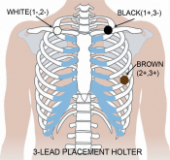 | Patient Preparation and Hook-up  - Select area over bone, avoiding muscle areas and breast tissue.  - Clean electrode sites aggressively with alcohol and use a razor to remove hair.  - Abrade electrode sites with a scrub pad or gauze. Allow sites to dry before applying electrodes.  - Firmly snap electrodes to the lead wires.  - Apply electrodes to appropriate sites.  - Press adhesive border firmly for consistent adhesion.  - To help alleviate tension, loop and tape lead wires down.

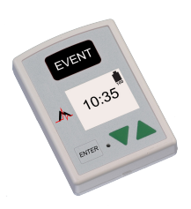 | TO START RECORDER FOR HOLTER  Step 1 - Insert formatted SD Card and battery into recorder. The screen will display recorder model and then “NorthEast Monitoring” information. Erase memory if prompted to do so. Press ENTER to continue to main menu.  Step 2 - Adjust Settings - If desired, adjust settings by using arrows - ▼and ▲ - to move the cursor and the ENTER button to select. Use arrows to navigate to General Settings menu and to adjust entries. Press ENTER to select and return to menu.  Step 3 - Enter Patient ID - From main menu go to New Patient screen to enter Patient ID. At least one character must be entered for Patient ID. Use arrows and ENTER to input ID and press EVENT when finished. (Hold down ENTER button to backspace.)  Step 4 - Start Recorder - ECG signal and quality will appear on screen. Recorder will start automatically after 10 minutes or by pressing EVENT button for 3 seconds. The time and battery level will appear on screen when recording Holter.  To stop recording, remove the battery from recorder. To remove card after recording, gently push inward to release. Never pull card out of slot, as it may damage the recorder. If screen displays a 15 second countdown, you can interrupt by pressing ENTER, ▼, ▲, and the EVENT button, in that order.
MESSAGES:
LEAD LOOSE – Occurs when the patient is not hooked up or if there is a problem with the hook up. The problem may be with an electrode, a lead, or the cable that connects the leads to the recorder. The message will continue to flash for about 10 seconds after corrected. When corrected, the ECG, then Time-of-day will appear on the screen. If you choose, you can turn this error message off via the main menu.

Battery LOW or FAILURE– Put in new battery before starting recorder.

Erase memory YES/NO - If the SD card has been used for a previous patient, you will need to erase now. If the card should not be erased as it has ECG data that you do not want to lose, you will need to remove it and put in a new formatted SD card.

Update Time and Date:
To Update Time and Date The recorder should save the correct time and date between uses, but if you ever need to update the time or the date, move the cursor to “Time and Date” and press ENTER. You can now update Hour, Minutes, Day, Month or Year by moving the cursor with the green arrows and pressing ENTER.

