HOLTER MONITOR INSTRUCTIONS

You cannot get the monitor wet. You will not be able to shower, bathe, or participate in any activity where the monitor and/or wires could get wet.

If you feel any abnormal symptoms (such as chest pain, shortness of breath, rapid heart rate, dizziness, etc.), please document them through the Holter monitor or on the diary sheet provided so that the cardiologist can see if the symptoms are cardiac related.

To enter symptoms through the Holter monitor, press the “EVENT” button, use the green arrows to find the symptom that best describes what you are feeling then press “ENTER”.

If any of the wires become unattached from the sticker/electrode during the recording period, you may reattach them like a button.

If any of the stickers come off the skin during the recoding period, please place the sticker back on to the same spot it fell from. (See diagram below for reference.)
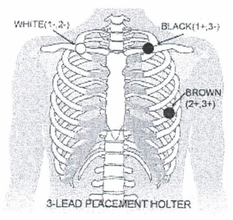

Prior to bringing the Holter monitor back to our office, please remove the stickers off your skin carefully and dispose of them.

The monitor needs to stay on until the time you are told to take it off (approximately 30 minutes before your return time.)

Please return the Holter monitor with the wires attached only.

**Patients are waiting to have their monitor put on so please return the monitor back on time, if you need to return the monitor at a later time, it needs to be approved by the technician. **

HOLTER MONITOR INSTRUCTIONS

- Do everything you normally do, except shower or bathe while wearing the Holter monitor.

- If you feel any symptoms related to your heart, please write down the time, what you were doing and the symptoms on the diary paper provided. If possible, please press the black event button located on the Holter.

- If any sticker comes off the skin during the recording period, please place the sticker back on the same spot it fell from.

- Prior to bringing the Holter monitor back to our office, please peel the stickers off your skin very carefully. The monitor needs to stay on until the time you are told to take it off.

*Patients are waiting to have their monitor put on so please return the monitor back on time. *

THANK YOU!

HOLTER DIARY
Record any ABNORMAL episodes by using the EVENT button on your device.
Abnormal events are:
Dizziness, flutters, skipped beats, chest pain, shortness of breath, etc.
Patient Information
Name: __________________________________
Date of Birth: _____________________________
Healthcare Number: _______________________

Hookup Date /Time: ___________________ Monitor #: ______________ Tech: ____________
Time | Activity | Symptom
(e.g. 10:15am) | (e.g. Walking up the stairs) | (e.g. Shortness of Breath)
Returning your Holter. Please remove stickers from the wires, place the Holter monitor in the blue pouch provided.

*Holter must be returned on time for the next patient’s appointment*

*If you have any questions, please feel free to call us at ______________.

